**UK Source URL Analysis**

URL: <https://www.legislation.gov.uk/new/2024-11-15?requested=2024-11-16>

This site is the official place of publication for newly enacted legislation in the UK. It also serves as the central platform for accessing the latest laws, regulations, and legal documents for the UK, Scotland, Wales, and Northern Ireland. The source URL aims to request new legislation published on 2024-11-15.

It has advanced search functionality to filter in Title (or keywords in title), Keywords in content, Language of legislation text, Year, Number, and Type. The Type can be filtered more specifically to All UK Legislation (excluding originating from the EU), All Legislation (including originating from the EU), All Primary Legislation, All Secondary Legislation, All Legislation originating from the EU, and All Impact Assessments.

The search functionality will be utilized using the sub-topics and sub-subtopics from the criteria document.

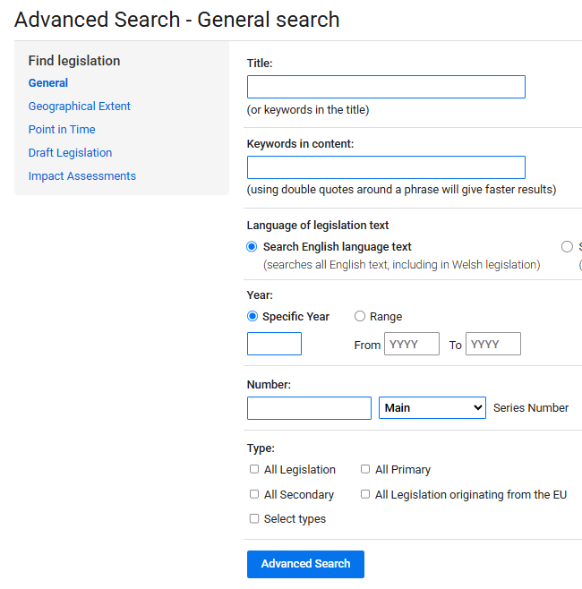

On the results page, the content of the site includes the metadata required (except for the date of adoption and the entry into force date). To obtain these dates, we need to access the specific legislation page. Entry into force date can be determined by looking at a section of the law itself, headed 'Commencement’.

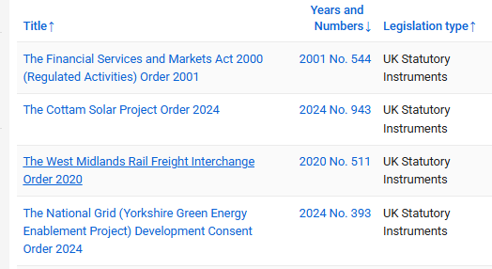

Regulation Type

Title and URL Source

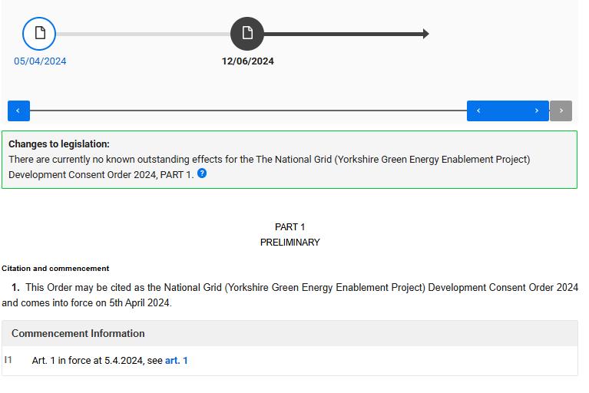

Entry into Force Date

Entry into Force Date

For some legislation, the relevant dates are easily accessible as these are publicly visible in the first section just below the title. However, for others, identifying the date of adoption requires manual review, such as checking when the legislation received Royal Assent (as indicated below).

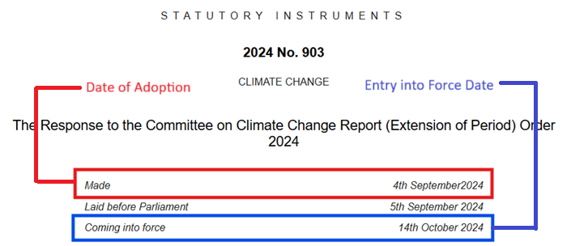

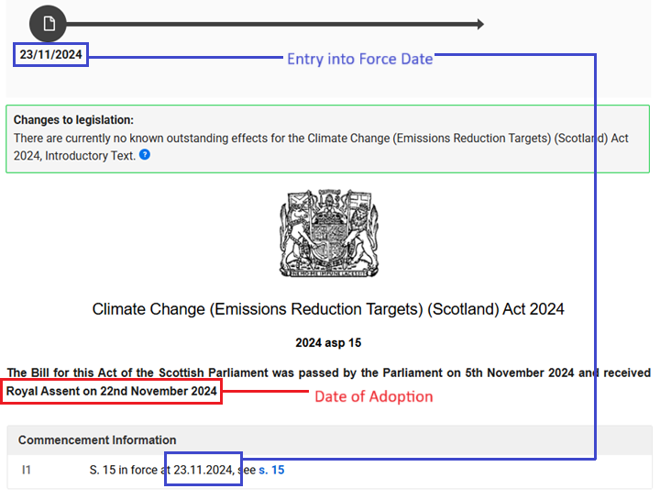

The search is limited to Statutory Instruments, Acts of Parliament, Ministerial Directions, Orders in Council, and Draft Legislation.

In the Advanced Search under Type, tick the following type of regulations to filter the result:

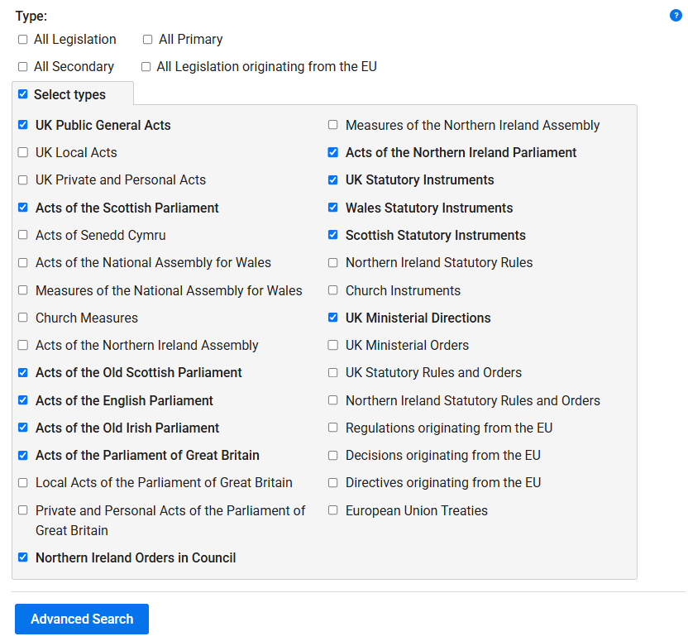

In the Search field, we entered either the keywords/subtopics found in the Title field or the Keywords in Content field—whichever provides the most relevant results.

Updated the list of search input to include sub subtopics. Refer to the list of keywords spreadsheet.